Crow and Hawk (Responsibility)

Once there was a beautiful black crow. She had a nest full of eggs perched on the side of a hill. Proudly she sat on her nest waiting for her eggs to hatch. She sat and sat, but nothing happened. Finally, tired of waiting Crow grew bored and flew away.

The eggs sat unguarded for some time, but still crow did not return. After a while Hawk flew by. Swooping over the nest she spotted the eggs. Later she flew by the nest again and saw that the eggs still remained unprotected. Hawk said to herself, “The mother of these eggs no longer cares for them. Poor little eggs, I shall sit on them until the mother returns.”

For days hawk patiently sat on the eggs warming them and waiting for the mother to return. Then one day the eggs began to hatch. Little black crows began to chip and push their way out of their shells. Calling for their mother, they chirped and chirped, but no mother came. Hawk looked down at them tenderly. “Poor little ones,” she said. “Don’t worry. I will look after you”.

With food and care the tiny crows grew bigger. Their black feathers grew glossy and beautiful and their wings grew strong. Hawk worked hard, feeding and caring for the young birds.

One day, Crow was flying over her old home on the hillside when she spotted the nest she had left so long ago. “Perhaps I should return to it,” she thought. Approaching the nest she saw Hawk taking care of a brood of healthy young crows. “How dare you Hawk!” she screeched, swooping down on the nest. “These are my very own baby crows and I want them back!”

Ruffling her feathers, Hawk spoke softly but firmly. “It’s true that you laid the eggs. But you flew off and left them unattended. Anything could have happened to the poor little eggs. I saw them and sat on them for days and days until they hatched. When they hatched I worked hard to feed them so that they would grow strong. It is I who has cared for them and it is I who will keep them.”

In this way Crow and Hawk argued their points. Finally Hawk declared. “Let us go to the King of the birds and see what he has to say.” Crow agreed and off they went to find Eagle.

When Eagle heard both sides of the story he asked Crow, “Why did you leave your nest?” Crow was silent. She could say nothing.

Eagle turned to Hawk, “How did you come upon these eggs?”

Hawk replied, “I was out flying one day when I saw a nest full of eggs with no one sitting on it. I waited to see if someone would come, but no one came at all.”

Crow began to screech, “But it was I who laid the eggs. They are mine and you are an impostor and a thief!”

“Yes, but you did not care for them,” replied Hawk. “It was I who sat on the eggs, I who hatched the eggs and I who fed the little birds.”

Eagle thought for a moment. “Let the young birds decide who is their mother” Turning to the young birds he asked, “Who is your mother then?”

In one voice the bay birds chirped, “Hawk is the only bird we call mother.”

“No, I am your real mother,” protested Crow.

The small birds chorused, “Yes, but you left us. Hawk stayed and cared for us. She is the only mother we know.”

And so it was finally settled. The little crows would stay with Hawk and not with Crow. And that is how precious things are lost when they are neglected.

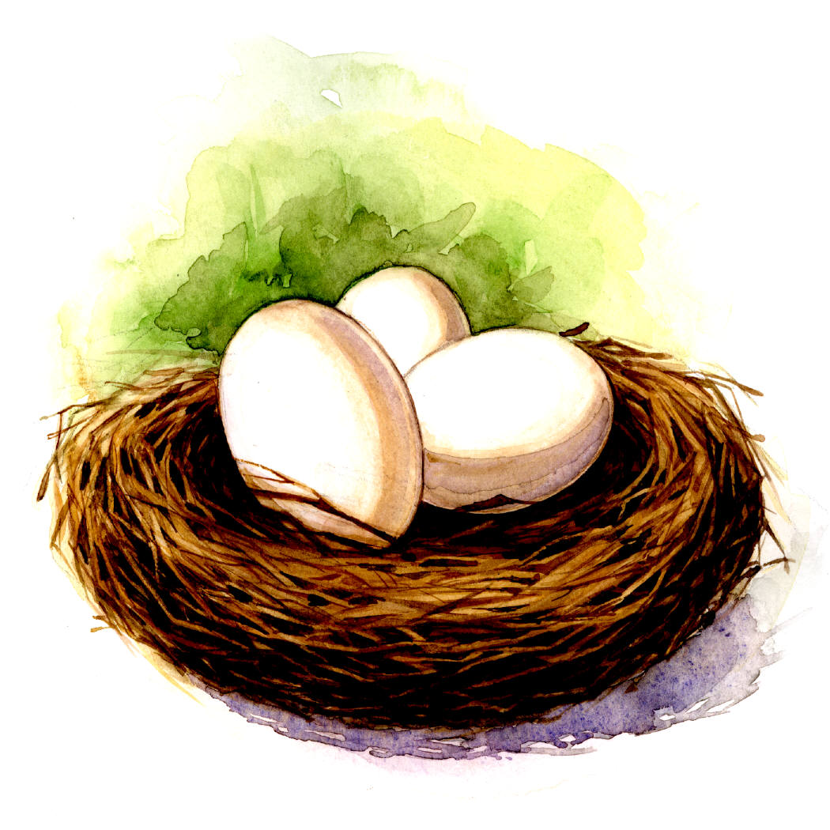

Questions and activities:

- Think of another title for the story.

- Why did Crow leave her eggs?

- Choose a different word in the sentences containing ‘unguarded’, ‘swooping’, ‘spotted’ (in paragraph 2)

- Describe how Hawk felt when she saw that the eggs were left unprotected.

- Find 8 strong verbs, 3 ly words, 6 dress up (adjectives) words.

- Why did Hawk decide to sit on the crow’s eggs?

- When Crow came back to her nest and saw Hawk with her young crows, she was angry. What do you think she could have said if she had been ashamed instead of angry. Make a speech bubble with her words.

- Now make another speech bubble with Hawks new words after he heard Crow speaking with shame.

- Hawk and Crow went to Eagle to settle their argument. Why?

- Why do you think Crow was silent when Eagle asked why she had left her nest?

- Why did Crow think the young birds belonged to her?

- What was Hawks argument?

- What do you think? Who should have the baby Crows and why?

- What does this story teach you?

