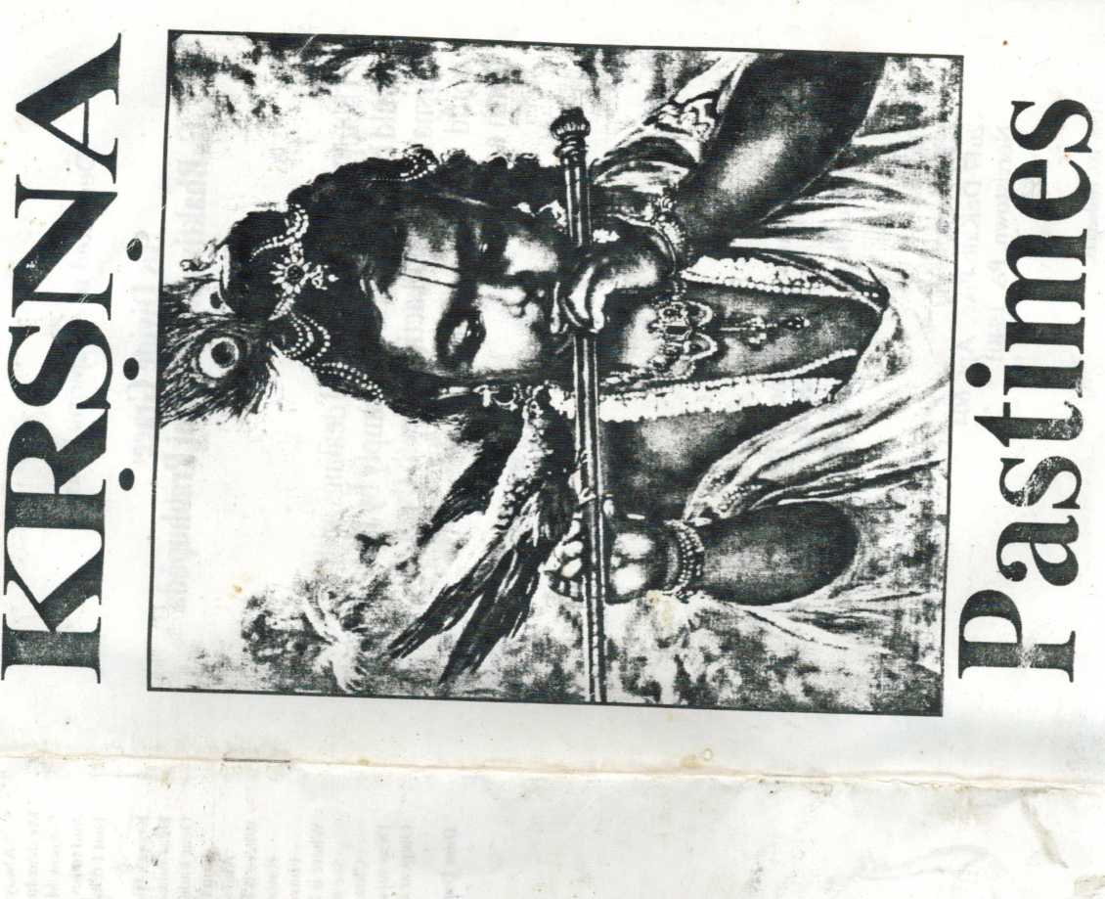
:n- >

Dedicated to my spiritual master

His Divine Grace

A. C. Bhaktivedanta Swami Prabhupada
“Their [Yasoda and Nanda] dealings with Krsna would be so powerful that simply by hearing of Krsna’s childhood activities with them, anyone could very easily cross over the nescience of birth and death.”
Krsna Book, Ch. 8
from Krsna Book, Vol 1 Yamlnl devi dasi Yaminl & son Jaya Caitanya Puskara dasa
Lyrics:
Songs & Piano: Vocals:
Cover Painting:
Orders:
J. K. Cappelletti
2617 DeKalb Pike, Apt. 604
Norristown, PA 19401
0 19% JKC Productions.
Advent of Lord Krsna
Once mother Barth, known ns Bhumi, assumed the form of a cow
She went to see Lord Brahma, with tears in her eyes, to tell
Of the burden on the earth from the unnecessary defense force
Of kings who were really demons but were posing as the rulers
Hearing of the distressed condition on the earth
Lord Brahma started at once for the ocean of milk
Bhumi and all the demigods accompanied him
And they prayed for Lord Visnu to save them
Within the heart of Brahma, Lord Visnu gave His reply
Brahma then told the demigods so they would all comply
And the message was that very soon. Lord Krsna would appear
To execute His mission upon the planet earth
The demigods and their wives should immediately take birth
In the dynasty of Yadu, wherein the Lord would come
And they should all remain there to assist Him
Once upon a time, Vasudeva, just after marrying Devaki Was going home on his chariot, along with her father’s dowry Kamsa, her brother, was driving, and as they were passing through A voice from the sky said “Kamsa, you fool Your sister’s eighth child will kill you!”
Kamsa grabbed Dcvaki’s hair and raised his sword to kill her But Vasudeva began to speak, astonished by Karhsa’s behavior “My dear brother-in-law, Kamsa, you are the greatest warrior How is it you are so infuriated you’re prepared to kill your sister On this auspicious day —why should you be so afraid?
Why should you be so afraid of death?
Your death is born along with your birth
At death this body is annihilated
See the planlworms change from twig to twig, carefully
So we change to accept our next body
These bodies are like we see in our dreams When awake, we forget just who wc have been We've also forgotten our bodies of the past And by our mental condition at death Accordingly, wc take our birth The luminous planets like the moon and stars Show their reflections on reservoirs The moving water makes the moon seem to move So we think, with these bodies we have some connection But (his is due to illusion
On account of illusion, wc think wc belong To a certain place, or the human form Such mental concoction and desire Are the cause of a body wc don't require Therefore, I beg you not to listen to your body anil mind’s dictation Kamsa, please consider: you have no danger from your sister If there are sons in the future, I promise I shall present them to you"
krsnu Pastime* page 4
In time Devaki and Vasudeva $»ave birth to eight sons and a daughter Vasudeva look ihc first-born son, and brought him before King Karhsu Kaiiisa was pleased that Ihe promise was kept And began to speak as follows:
“My dear Vasudeva, you need not present this child to me The danger is to come from the eighth-born son of Devaki Why should I accept this child unnecessarily?
You can take him back —you can take him back”
Narada Muni was anxious to accelerate Lord Krsna’s descent Narada Muni went to Kaiiisa the king, and spoke this warning:
“Kaiiisa, beware, the demigods are taking birth In the families of cowherd men and their wives,
And on Ihe other side, Vasudeva and others
Born in the family of Vrsni, of the Yadu dynasty
All are preparing for the appearance of the Lord
Kaiiisa beware, the demigods are taking birth
They have come to assist Lord Visnu, Kaiiisa become alert
The demigods are taking birth, Kaiiisa become alert
Lord Visnu will be coming soon”
When he was informed by Narada, Kaiiisa became afraid He imprisoned his lather Ugrasena, Devaki, and Vasudeva Year after year Devaki gave birth to another son And thinking they might be Krsna, Kaiiisa killed them one by one
Vasudeva and Devaki are prison-bound by Kariisa Lying in Devaki’s womb is My expansion Sesa Yogamiiya, transfer Sesa to Ihe womb of Rohini Then I shall become the Son of Vasudeva and Devaki In Vrndavana, you take birth from Nanda and Yasoda As their daughter, you’ll be known as Durga and Ambika
The Lord of the whole creation, Krsna, entered within the mind of Vasudeva Then like rays of the setting sun are transferred to the rising moon So Lord Krsna’s form of eternity was transferred to the mind of Devaki From the mind of Vasudeva within Ihe prison of King Kaiiisa Seeing the beauty of his sister, Kariisa knew who had come within her “What can be done with Devaki? Krsna is in her womb Seeing her wonderful beauty, surely Lord Visnu has come If I kill Devaki now, I would lose my reputation And if Krsna is to kill me, no one can stop His mission I will await the inevitable future, then kill the baby when He is delivered"
Prayers by the Demigods for Lord Krsna in the Womb
Dear mother Devaki, within your womb The Supreme Personality of Godhead has come Krsna will appear with Balarama Do not be afraid of your brother. King Kariisa
Lord Krsna is true to His vow, and He comes within this material world So that the pious will be protected, and the demons will be destroyed
Krsna Pastimes page S
Before creation, Krsna was existing, and within Him everything is resting Alter creation, Krsna will remain, so He is the truth for all of time Our dear Lord, You are personally here to show Your actual form And one can meditate upon Your lotus feet at any lime Your feet arc the boat to cross the ocean of material existence And devotees find that ocean reduced to the water in a calf's hoofprint So they simply cross over immediately
And the boat of Your feet is never taken away from this side of that ocean Your transcendental form and Your holy name Your pastimes and qualities are all the same This absolute nature that is Yours (’an only be known to one who serves With love and devotion, oh dear Lord Such a soul returns to the spiritual world You are always unborn, we find no reason for You to descend Demons can be killed by material nature So it must be of Your own sweet pleasure You come and meet with Your loving devotees Oh Lord, please protect us throughout our lives Dear mother Devaki, within your womb I he Supreme Personality of Godhead has come Krsna will appear with Balarama Do not be afraid of your brother,
Do not be afraid of your brother, King Kariisa

Birth of Lord Krsna
When the time was mature for the Lord to appear Signs of good fortune were everywhere
The stars and planets above the earth —all were adjusted for Krsna’s birth
The rivers were flowing full of waters, lakes were filled with lotus flowers
Within the forest, birds were singing; peacocks danced and the wind was pleasing
Brahmanas lit the sacred fires and their minds were joyful to hear
Loud vibrations of transcendental sound proclaiming Lord Krsna would soon appear
I he time was mature for the Lord to appear
And signs of good fortune were everywhere
“Sec the wonderful child, born as a baby with four hands
Holding the signs of Lord Visnu, the Supreme Personality of Godhead
He is dressed in yellow silk, wearing jewels and ornaments
In my mind, I will have a celebration
And give many thousands of cows to the brahmanas
See His eyes are lotus-like, and His hair is fully grown
He is dazzling like a bright blackish cloud
He is very wonderful!”

Piitana Killed
Piitana was a khecari witch, and so she could fly in the sky
Although she was evil, she entered Gokula where everyone let her pass by
Because of her smiling beauty, and the lotus in her hand
Yasoda and Rohini said that the Goddess of Fortune had come
krsil.1 I’asliilK's |mji^{c} *■
Palana was a sword in a decorated case Because of the poison upon her breast She was a demon, Krsna could tell So Me sucked out her milk and her life as well Hare Krsna Hare Krsna, Krsna Krsna Hare Hare Hare Kama Hare Rama, Rama Rama Hare Hare

Sakatasura
Baby Krsna kicked the cart, it fell to the ground and broke apart Sakatasura was pushed, along with the cart, upon the earth

Salvation of Trnavarta
Trnavarla came from Karhsa, shaped like a whirlwind Putting Krsna on his shoulder, darkening Vrndavana Dust storm all around, baby Krsna can’t be found Yasoda is crying upon the ground But baby Krsna made Himself as heavy as a mountain He caught Trnavarta’s neck, and made him fall down Down, down, to the ground, sinful Trnavarla Demons have to die, but Krsna is alive Down, down, to the ground, sinful Trnavarta Demons die away, but Krsna is saved.

The Oopis l.odge Complaints
The gopis went to lodge complaints at the house of mother Yasoda:
“Dear Yasoda, why don't you restrict your naughty Krsna?
f le comes to our house with Balarama, in the morning and the evening
Just to let the cows go loose before the time for milking
So when we go to milk the cows, there is no milk remaining
All the calves have drunk it up and Krsna stands there smiling
So we give Him a warning that this simply has to stop
We cannot keep returning to our houses without any milk
Krsna and Balarama break our pots and throw them hither and thithe
Then we all collect our stock of yogurt, milk and butler
And hang it from the ceiling, high upon a swing
But Krsna piles wooden crates on the grinding machine
And if He cannot climb and reach. He gets a stick and makes a hole
Krsna feeds the monkeys then until they are completely full
And when they won’t take any more, Krsna chides “Dear mother,
See the monkeys will not eat it —what is the use of your butter?”
If we keep our yogurt in a dark place for hiding Krsna finds it anyway because of the shining Of all His jewels, pearls and ornaments If you took them all away, what would be the difference?
Their bodies have effulgence that shines with such a light
Both of Them see everything, even in the night
All day They make arrangements to come and steal these things
Yasoda, please consider what disturbance Their naughtiness brings!

Vision of the Universal Form
Balarama went to Yasoda to tell her that Krsna had eaten clay She went to Krsna saying, “What have you eaten all alone today?
Your brother and friends have combined together And come complaining to me”
“Mother, if you think they are truthful.
Look within My mouth and see
They are all speaking lies, I never ate clay
Balarama was angry while playing today
Anil he complained so you would be angry and come to chastise Me" “All right," said Yasoda, “open up Your mouth and I shall see"
Krsna opened up His mouth, just like an ordinary boy
And Yasoda saw within it everything in creation
Mountains, islands, oceans, seas, planets, fire, moon and stars
Outer space spreading in every direction
Spiritual nature, material nature too
Objects of the senses, like smell and touch and sound
Water, sky, the demigods, and every living being
Consciousness, activity, and eternal time were found
Along with all things needed for cosmic manifestation
She even saw herself feeding Krsna with her milk
Mother Yasoda was struck with awe and began to wonder what she saw She thought it must be mystic power attained by her son So she prayed with all her might to the Lord of everything in her sight Because she did not know from where these visions had come “Oh, Supreme Personality, kindly please protect me Under illusory energy, I'm thinking I’m this body Your external potency gives me this misconception I think that all these lands are mine, and Nanda Maharaja my husband” Krsna saw Yasoda was thinking philosophically Then He expanded His internal energy Just to bewilder her with motherly affection And make her forget all about her speculation No longer concerned with the visions that she saw No longer the feelings of reverence and awe She said "Now. let this incident be forgotten;
I do not mind. Here is my son —let me kiss Him”

Mother Yasoda Itinding laird Krsna
Krsna stole the butter and ran from Yasoda Yasoda was quick to pick up a stick She found baby Krsna on the grinding mortar Giving the monkeys all of the butter Seeing her near. He lied in fear Krsna ran and Yasoda ran, Krsna ran and Yasoda ran Her body was heavy and her waist was thin But somehow she ran and captured Him I le was almost crying. His eyes were afraid.
Seeing I lim so, she threw her stick away
Krsna Pastimes page 8
Yasoda endeavored to hind Him up, so she went to the house to get some rope She did not know the Supreme Personality can’t be bound by any yogi He has no beginning. He has no end. He’s all-pervading and unlimited He Himself is the whole cosmic manifestation Appearing as her child, still He had no limitation
Yasoda was trying to bind her son and went to get more rope But again and again, lied together, they were two inches too short What to do! She was smiling But she said, “How is this happening?”
Krsna is bound by the love of His devotee mother Seeing her hard labor, compassionate upon her He agreed to be bound by the ropes of Yasoda No one can control Krsna The devotee can only surrender Krsna can save him, Krsna can kill him But he never forgets his position In the same way, Krsna gets transcendental pleasure By submitting Himself to the protection of Yasoda Krsna is bound by love; He can’t be found any other way Hare Krsna Hare Krsna, Krsna Krsna Hare Hare Hare Kama Hare Rama, Rama Rama Hare Hare

Deliverance of Nalakuvara and Manigriva
Nalakuvara and Manigriva were cursed to stand as trees by Narada
Just to end their false enjoyment with intoxication
Proud of their wealth in the family of demigods
They now stood as trees in Nanda’s courtyard
Knowing the end of the curse would come
When Lord Krsna appeared before them
Krsna, tied to the grinding mortar, crawled till it stuck in between the trees And pulled on the rope so the trees fell down, and out came the two personalities Their bodies were shining all around As they came before Krsna bowing down “Oh Lord, You are the cause of creation Birth and death, as well as liberation
We pray to serve You by hearing Your transcendental activities By thinking of Your lotus feet, and speaking about Your glories”
Krsna, smiling, told the demigods “You are very fortunate in this world
You saw the great sage Narada who is always serene and merciful Being in his presence is like being in the sun Nothing can impede your vision One is liberated in that light, from that moment on You have developed love for Me, and will never take birth again Remain in the mood of devotion, and go back to your father’s residence in heaven They circumambulated Krsna, and returned to their heavenly planet Nanda Maharaja came and untied his wonderful, little son.
The elderly gopis took him to the courtyard and clapped their hands in fun Krsna began to elap along with them
And He sang and danced like a puppet in their hands *End of Side A*
Killing Hie Demons Vatsasura and Bakasura - (Medley)
Sometimes Yasoda would ask Krsna to bring her a plank for silting
Although it was too heavy. He brought it to His mother
Sometimes while worshipping Narayana
His lather would ask Him to bring wooden slippers
And with great difficulty, Krsna would bring them on His head
Sometimes something was too heavy, and Krsna would simply move His arms
In this way, every moment, every day
He was the reservoir of pleasure to his parents, Nanda and Yasoda
One day a fruit vendor came before the house of Nanda Maharaja
Calling "Anyone who wants some fruits, please come and take them from me”
Child Krsna immediately took some grains
And went to gel fruits by trading them
Hut He didn’t hold His little palms very tight
So the grains fell down in the vendor’s sight
Captivated by the beauty of the Lord, the vendor filled His hands with fruits
Meantime, the basket of fruit became filled with jewels
The Lord is the bestower of all benediction
If someone gives something to the Lord
He is not the loser, he is the gainer by a million times
The cowherd men consulted together How to stop the great disturbances in Mahavana On account of the demons that were coming there Disturbing the peaceful situation
“Considering Putana, the Whirlwind Demon, and falling trees
Only by the grace of Lord Hari was the child Krsna saved
Let us all leave. We should be cautious and reside where we can live peacefully
L.et us go to the forest of Vrndavana, where there are newly grown plants
And herbs, and suitable pasturing ground for our cows
We and our families, the gopts with their children, can live there
Govardhana Hill is near there, and there is newly grown grass for the animals
Let us go immediately to that beautiful place, there is no time to waste
Let us prepare our carts now, and keep all the cows in front”
Hearing Upananda, the brother of Nanda, all the cowherd men agreed Everyone loaded all their household things, and prepared to go to Vrndavana Cows and bulls, along with calves, were placed in front The men surrounded their flocks, holding bows and arrows,
And blew their horns and bugles So with tumultuous sound, they started for Vrndavana And who can describe the damsels of Vraja?
Seated on their carts, dressed very beautifully They began to chant all the pastimes of Krsna Yasoda and Kohini sat with the boys upon their laps Riding on the cart, talking to Krsna and Balarama And feeling the pleasure of such talks,
They looked very, very beautiful
Krsna Pastimes page 10
At this time Krsna anil Balarama were given charge of the calves Sometimes They played on Their flutes
And played with amalaki fruits and bacl fruits, like small children play with balls Along with other cowherd boys, Krsna and Balarama went to the pasturing ground Tending the calves. They sometimes danced With Their ankle bells making a tinkling sound
Sometimes They imitated bulls and cows by covering Themselves with blankets They imitated sounds of animals and birds
Enjoying Their childhood pastimes, apparently like ordinary children
One day while Krsna and Balarama were playing on the bank of- the Yamuna
A demon came in the shape of a calf, and its name was Vatsasura
He came there intending to kill the brothers, while mingling with the other calves
Krsna, however, noticed this and told Balarama of the demon's entrance
Both brothers then went together and
They followed him, and sneaked up upon him
Krsna caught hold of the demon calf by the two hind legs and tail
Whipped him around very forcibly and threw him into a tree
The demon lost his life and fell down from the top of the tree to the ground
Krsna’s friends said “Well done!"
And the demigods in the sky showered flowers in great satisfaction
The boys would daily go to the bank of the Yamuna
To water the calves, and the boys also drank
One day after drinking, while they were sitting on the bank
They saw a huge animal which looked something like a duck
It was as big as a hill, its top was strong as a thunderbolt
They became afraid of this beast named Bakasura
He was a friend of Karhsa’s, appearing on the scene
He swallowed Krsna up, and all the boys with Balarama
Became almost breathless, as if they had died
But when Bakasura demon was swallowing Krsna
He felt a burning, fiery sensation
This was due to the glowing effulgence of Krsna, so he quickly threw Him up And tried to pinch 1 lim in his beaks —Bakasura did not know That Krsna was playing the part of a child
But was still the original Father of Lord Brahma, the creator of the universe
The child of mother Yasoda, the reservoir of pleasure
Maintainer of saintly persons
Caught hold of the beaks of this great, giant duck
And before His friends, bifurcated his mouth
As easily as a child splits a blade of grass —Krsna!
From the sky, the denizens of heaven showered flowers
Like the cameli, on Krsna
As a token of their congratulations
Accompanying the flowers there were bugles and drums
Conchshells sounded, and the boys were struck with wonder
Seeing Krsna they all were so pleased.
It seemed they had regained their very source of life As soon as they saw Krsna coming towards them
Krsna Pastimes page 11
They one by one embraced the son of Nanda and field Him to their chests After this, they assembled the calves and began to return home When they arrived, they began to speak Of the wonderful activities of Nanda's son
They all heard the story, gopis and cowherd men, and fell great happiness Naturally they loved Krsna and conversed amongst themselves How so many demons in fierce bodies attacked Krsna just to kill Him Hut by the grace of Lord Hari, they could not even cause a slight injury But they died, like small flies in a fire
Thus they remembered the words of Gargamuni who foretold That this boy would be attacked by many demons Seeing that Krsna was saved from the mouth of death They began to see His face with great love and affection They could not turn their faces from this vision Talking about Lord Krsna and Balarama,
They forgot their anxieties in material existence;
They forgot the three-fold miseries of this world
Krsna and Balarama imitated monkeys of Lord Ramacandra
Who constructed a bridge on the ocean
And Hanuman who jumped over to Ceylon
Krsna and Balarama, Krsna and Balarama
The Killing of Aghasura
Krsna, Krsna, let's all play, going to the forest Sound upon our flutes and horns, keep the calves before us With a stick, lunchbag too, we’ll be happy seeing You Krsna beautiful and blue —Hari, Haribol
Krsna, Krsna, now we’re here, dancing all together Decorate with twigs and leaves, clay and peacock feathers Putting flowers in our hair, Krsna’s pleasure is our care Loving Him we have no fear —Hari, Haribol I lis name is Aghasura, he’s fat and round I lis lip is in the sky, his chin is on the ground I lis wide-open mouth is just like a cave His tongue appears like a broad traffic-way From his mouth a hurricane blows, from his eyes fire glows Now he is waiting to swallow us all But Krsna will kill him like Bakasura Krsna will save us, Krsna will save us, Krsna will save us Krsna, Krsna, Krsna!
(Aghasura)
Everyone has entered but Krsna Who killed my brother and sister I am waiting for Him to come in I low can I save my intimate friends?
I will enter within Alas! Alas!
Jaya Krsna, jaya Krsna, He brought us back to life
Jaya Krsna, jaya Krsna, just see that dazzling light
Jaya jaya, all glories to the Supreme Personality of Godhead!
Hare Krsna Hare Krsna, Krsna Krsna Hare Hare
Hare Rama Hare Rama, Rama Rama Hare Hare
(Krsna)
(Demigods)
(Boys)
(Demigods)
Krsna Pastimes page 12
Killing of Dhcmikiisura
Dear Balarama, Your arms are strong Dear Krsna. You can kill the demons
Nearby is the Talavana forest, lull of palm trees filled with fruits No one can get them because of a demon there: Dhcnukasura Dear Krsna and Balarama, only You can kill such demons All the birds and animals have left that forest filled with fruits Please let us go there, we like the aroma —don't You smell it from here Today in the forest of Talavana, Krsna and Balarama Killed the Dhcnukasura by wheeling him around and around (Gopis)
All day we think of Krsna in the forest
Or we think of Him herding cows in the pasture
Whi n we see Krsna returning, all our anxieties are relieved
And seeing His face like a lotus flower, we laugh and smile again
Hare Krsna Hare Krsna, Krsna Krsna Hare Hare
Hare Rama Hare Rama, Riima Rama Hare Hare
Subduing Ksiliya
Krsna, Krsna, wrapped in the coils of Kaliya serpent
How can we bear to sec You in such danger
Krsna, we have dedicated everything
But now we stand here unable to help You
Nothing is more dear to us than Krsna
Seeing I lim enveloped by the serpent
We find the world becoming vacant
Thinking about His smile and friendship
Krsna, Krsna, wrapped in the coils of Kaliya serpent
flow can we bear to sec You in such danger —You arc the only shelter
Devouring the Forest Fire
In the forest, Krsna’s dancing, cowherd boyfriends offer praise:
“Dear brother. You are dancing very nicely," they say Lord Krsna and Balarama, cowherd boys too Are tending the cows and blowing their flutes And They enter where Bowers arc always in bloom - The beautiful forest of Vrndavana
Dear Krsna and Balarama, dear Krsna and Balarama We are now burning from the heat Let us take shelter of Your lotus feet (Gopis)
It is the evening, Krsna and Balarama
Along with the boys and cows are returning
To Vrndavana, playing Their flutes
Now They're approaching. Krsna and Balarama
All through the day. They are in the forest
in Their absence, we think one moment to be like twelve years
Hare Krsna Hare Krsna, Krsna Krsna Hare Hare
Hare Rama Hare Riima, Rama Riima Hare Hare
Delivering the Wives of the Itrahinaiias
Mothers, gather up a least, hurry let us lill the pots Krsna and Balarama must cat, now They are calling lor us Husbands, brothers, sons and friends All have asked us not to go
But come let us bring Hint a feast —Krsna is our lift and soul Worshiping Govardhana llill
My dear father, what is this plan for a sacrifice? Please explain it to Me Is it a Vedic injunction, or a popular ceremony?
My dear boy, this function is traditional Wc have to thank Lord Indra for kindly sending rail fall We cannot live without the rain for farming and producing grain My dear lather, let us not worship Indra, we have our duties to perform Rain will come from the clouds above, and not by worshiping him Rain is falling on the ocean, and on the land as well
Besides, we have our relationship with the brahmana men and Govardhana Hill We are satisfied living in this forest of Vrndavana So let us take (he grains and ghee collected lor the yajna To satisfy our Govardhana, and nevermind Lord Indra!
Dear friends, please prepare rice, dahl, halavah
Puri, pakora, laddu, rasagulla, sandesa, sweet rice, then call the brahmanas Grains for the brahmana men chanting the Vedic hymns
Decorate the cows, feed them well, keeping them in front, circumambulate the hili Govardhana puja, Govardhana puja Lots of prasada, even for candalas Govardhana puja, Govardhana puja
If you neglect Govardhana worship, you will be killed by the snakes on the hill
All the people of Vrndavana, for your good fortune
And the fortune of your cows as well —worship Govardhana Hill
Sarhvartakn cloud, go destroy Vrndavana
They have slopped the sacrifice which was meant for me
Sariivai taka cloud, inundate their homes
They have taken Krsna so seriously
(io and I will follow you, riding on my elephant
Great storms will come with me to give the proper punishment
Pour down the rain now, all you clouds
They should be destroyed along with their cows
Indra’s sending rain like sharp, piercing arrows See it falling down as thick as pillars Thunder, lightning, ice is falling too Heavy winds are blowing, what can wc do?
This is a dangerous situation Clouds are pouring water without cessation Krsna! Save us! You are very strong All the land will Hood before very long
krsna Pastimes page 14
Every living creature is trembling from the cold And we find no source of deliverance Krsna, You are affectionate to Your devotees Now please save us from angry Indra,
Krsna, Krsna, dear Krsna!
My dear father, my dear brothers, dear inhabitants of this land
Now I have lifted the hill of Govardhana
Don’t be afraid and think it will fall
From the little finger of My hand
You have all been afflicted by heavy rains
And winds that were sent by Indra
Now be protected by this big umbrella
Bring your cows and come under the hill.
Bring your cows and come under the hill —be happy together
We're not hungry, we're not thirsty, we don’t even want to sleep Krsna lifted up the hill, and then we entered underneath We're not hungry, we're not thirsty, we don’t even want to sleep We just wonder how Krsna held the hill for one whole week!
Be happy together / Krsna, we are happy all together Hare Krsna Hare Krsna. Krsna Krsna Hare Hare Hare Kama Hare Kama. Kama Kama Hare Hare
My dear Lord, being puffed up by my false prestige I thought You took my offerings, and this offended me But I am the offender, with my anger and ignorance Sending rain and hailstorms to cause You disturbance You have shown me Your kindness, although I am only foolish Within this material world, many fools like me Will falsely claim to be God
But without giving punishment. You find the means So their false pride will soon be destroyed Coming to my senses, I now take shelter unto Your lotus feet You are my master, the most powerful, the son of Vasudeva The Supreme Lord Krsna Please excuse me, I am fool number one And bless me so that I may never act that way again
My dear Indra, I have stopped your sacrifice
To show My causeless mercy
And to revive your memory
That I remain your master eternally
I am the master of the demigods as well
Everyone should always remember that I am the Supreme Lord I can show anyone my favor, or chastise anyone For no one is superior to Me If I find that someone is falsely proud Of opulence that came from Me Then I show My favor by withdrawing it And that is My causeless mercy
Return to (he heaven, remain there as the king Always he My servant, lor 1 am the Supreme My clear Indra, I have slopped your sacrifice To show My causeless mercy And to revive your memory That I remain your master eternally
Krsna’s Hiding from the Gopis
Dear tulasi, where is Krsna? Dear blackberries, where is Krsna? Dear kadamba flower, where is Krsna —where is Krsna now?
Don’t be afraid of torrents of rain And severe hurricanes, I'll save you Where is Krsna —where is Krsna now?
Rascal Kaliya, leave this place
I have descended on the earth to punish all kinds of miscreants Where is Krsna —where is Krsna now?
See the flames of the fire are coming Close your eyes, I’ll save you
Dear tulasi, where is Krsna? Dear blackberries, where is Krsna? Oh pear trees, oh asana trees, where is Krsna now?
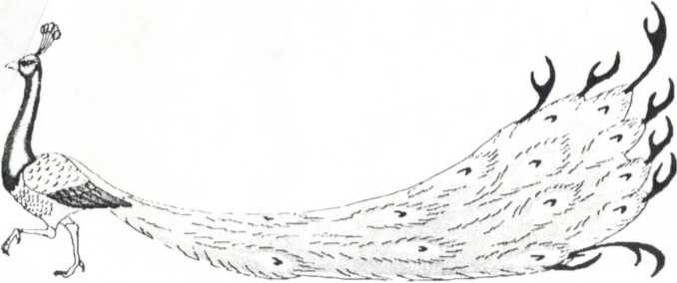
Dear Dainodara, dear Madhava, please don't go to Mathura

