Songs for Krsna's Kids

Learning Sastra Thru Music
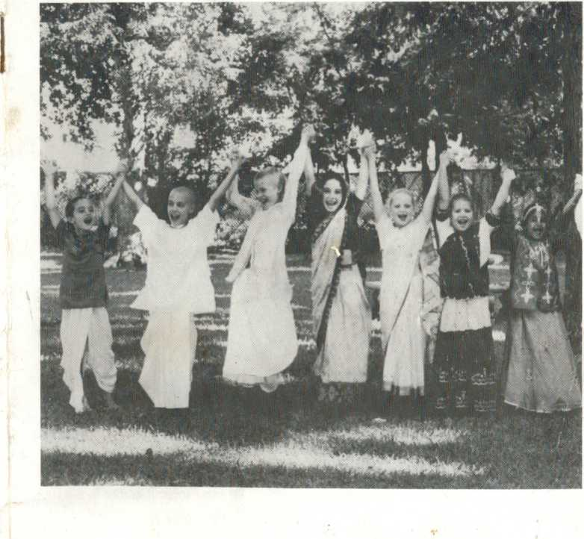
Song Book Accompaniment for Song Tape Volume One

'

Contents
Side A
- The 26 Qualities of a Devotee 1
- Verses Describing the Qualities of a 2 Devotee
- The Names of Krsna in the Bhagavad-
gita 4
- The 25 Qualities of Srimati Radharani 7
Side B
- Sri Nama 8
- Sri Dasavatara-stotra 10
- Jagannatha Swami 11
- Radha Krsna Bol Bol 12
>30v2j0\2j0 303j0 viDvSb 3030

Credits
Narration
Jahnava devi dasi
Lead Vocals
Mahatma dasa: Verses, Sri Nama, Qualities of Radharani, Names in the Gita
Vrakesvara Pandita dasa: Radha Krsna Bol Bol Jahnava devi dasi: Qualities of a Devotee, Names in the Gita, Indranilamani devi dasi: Dasavata ra - star a, Qualities of Radharani Dallas Gurukula: Jagannatha Swami
Background vocals
Candravali devi dasi and Indranilamani devi dasi: Radha Krsna Bol Bol
Los Angeles Gurukula - Gaura Nitai, Krsna Sakti, Sumukhi. Sita: 26 Qualities of a Devotee
Dallas Gurukula - Radhika. Jahnavi, Gayatri, Amrita, Radha Kunda, Bhadra, Kaliya Krsna, Sesa: All other songs
All songs and music written, arranged and played by Mahatma dasa except for:
Dasavatara-stotra: Sarvatma dasa and Antonio Artese
The 26 Qualities of a Devotee'. Michael Caulton and Mahatma dasa
Radha Krsna Bol Bol: Krsna Caitanya dasa and Mahatma dasa
Adaptations of songs and verses in English by Mahatma dasa.
Engineered and recorded by Mahatma dasa
Mixed and mastered by Mahatma dasa and Bhakta Raoul
Cover photo: Jahnava devi dasi
Cover design: Jahnava devi dasi and Mahatma dasa
Thanks to Arci devi dasi who inspired this project, Tapasvini devi dasi and Krsna Kanti Prabhu who gave the ideas, Krsna Caitanya Prabhu (my engineering instructor) and his wife Vaisnavi devi dasi who let me live in their house while 1 was working on the music, Nandulala Prabhu in Los Angeles and Dharina dasa in Dallas, both who allowed me to set up my studio in their homes, Indranilamani devi dasi for her time and enthusiasm, the Dallas devotees for their support and cooperation, and my wife Jahnava devi dasi who made many sacrifices to allow me the time needed to work on this project.
In order to continue our service of providing devotional tapes for children, we beg you to not allow others to duplicate this tape. Additional copies of the tape and song book can be obtained by sending $6.95 (add $2 for overseas shipping) to Martin Hausner, 5430 Gurley Ave. Dallas, TX 75223
i
<
© 1997 Martin Hausner, Sounds Divine Productions

The 26 Qualities
of a Devotee
- He is kind, humble and fixed In the Absolute Truth
He is equal to everyone And is faultless and charitable
- He is mild, clean and simple A well wisher to everyone He is peaceful and desireless And completely attached to Krsna
- He is steady and self controlled Meek and respectful
He doesn't eat more than he needs He is sane and without false prestige
- He is grave and compassionate A friend to all living beings He is poetic, expert and silent These are his 26 qualities
Hare Krsna Hare Krsna Krsna Krsna Hare Hare Hare Rama Hare Rama Rama Rama Hare Hare

Verses Describing
the Qualities of a Devotee
Tolerance
matra-sparsas tu kaunteya sltosna-sukha-dukha-dah agama-payino 'nityas tarns titiksasva bharata
Happiness and pain come and go Just like the summer melts the winter snow Some things feel good and some feel bad Tolerate them without becoming sad
(Bhagavad-gita Chapter 2 Verse 14)
Steady and Desireless
prajahati yada kaman
sarvan partha mano-gatan atmany evatmana tustah
sthita-prajnas tadocyate

When a man gives up all kinds of desire That burn the in heart like a terrible fire And when his mind is thus purified With the self he'll be satisfied
(Bhagavad-gita Chapter 2 Verse 55)
Equal to Everyone, A Well Wisher to All
vidya-vinaya-sampanne
brahmane gavi hastini
suni caiva sva-pake ca
panditah sama-darsinah
The humble sage with knowledge true Sees equally both me and you He also sees all beings in common Even a cow, dog, elephant or brahmin
(Bhagavad-gita Chapter 5 Verse 18)
Equal to Everyone
yo mam pasyati sarvatra
sarvarh ca mayi pasyati
tasyaham na pranasyami
sa ca me na pranasyati

For one who sees Me in all that be And sees everything in Me I am never lost to he And he is never lost to Me
(Bhagavad-gita Chapter 6 Verse 30)
Tolerance, Merciful, A Friend to All Living Beings, Peaceful titiksavah karunikah suhrdah sarva-dehinam ajata-satravah santah sadhavah sadhu-bhusanah
A saint is peaceful and tolerant He's merciful and everyone's friend He lives by the scriptures, has no enemies And he has all good qualities
(Srimad-Bhagavatam Canto 3: Chapter Twenty-five, Text 21)
i
>
Meek and Respectful trnad api sunlcena taror iva sahisnuna amanina manadena kirtaniyah sada harih
Feeling like the grass that's on the ground Quiet like a tree that's being cut down Respecting others not wanting fame
One can always chant the holy name
(Siksastaka Verse 3)

Names of Krishna in the Bhagavad-Gita
- Madhava is the husband of the goddess of fortune.
Hrsikesa is the master of the senses and the mind.
Kr$na is He who attracts everyone. Govinda is He who gives pleasure to the senses and cows
- Acyuta is He who never fails His devotees.
Var§neya is He Who is born in the Vrsni family
- Kesava is He who has the most lovely hair.
Janardana is He who removes all our ignorance.
Isvara is the best among the controllers. Mahabahu is He who has big strong arms.
- Arisudana is He Who's the killer of His enemies
Prabhu is He Who can do all things expertly
- Purusottama is He Who is better than everyone.
Bhutabhavana is He who creates and He who maintains.
Bhagavan is He who has all opulence. Devadeva is the Lord of all the demigods.
- Vasudeva is He Who is everywhere we see.
Bhutabhrt is He Who maintains all living entities
- Jagatpati is He who controlls and protects everyone.
Ananta is He who is unlimited. Kamala-patraksa is He who has lotus
eyes.
Paramesvara is the controller of everything.
- Deva is praised with awesome prayers. Deva travels everywhere.
Deva is equal to everyone.
And Deva shines just like the sun.
- Hari is He who removes all our suffering. Visves-vara is the controller of the universe.
Mahatma is a very great personality.
Devesa is He who is Lord of all the lords.
- Bhutesa is He Who's the master of all living entities.
Yogi is He Who's the master of His own
energy.
- Visvarupa is He whose form is the universe.
Deva-vara is the best among the demigods.
Jagan-nivasa is the shelter of the universe.
Amita-vikrama is He whose courage no one can impede.
- Visnu is He who pervades all that be Yogesvara is He Who's the master of all (mystics) yogis.
- Anantavirya is One with unlimited power Sahasrabahu is He who has a thousand arms.
Visvamurti is He who pervades the universe.
Kesinisudana is He who killed the horse named Kesi.
- Madhusudhana is He who killed the madhu demon easily.

Yadava is He who is born in the Yadu dynasty.
15) Deva is praised with awesome prayers Deva travels everywhere Deva is equal to everyone And Deva shines just like the sun

The 25 Qualities of Srimati Radharani
- She is sweetness personified And a fresh young girl
She knows how to dress so nicely And is cunning too
- She can give shelter to all devotees And is very grave
She is always so brightly smiling And Her eyes always move
- She is always so merciful And always gives respect
She can speak nicely and sweetly And sings expertly
- She is modest and She is gentle And always patient
She is enjoyed only by Krsna And is always very shy
- She has all auspicious marks On Her transcendental form She can excite Lord Sri Krsna By Her sweet fragrance
She is the abode of love Of the people of Gokula She is always affectionate To the elders and the young
She is always on the highest stage Of devotion to the Lord She is obliged by the dealings Of her associates
She is the greatest among Krsna's girl friends She always keeps Krsna Under her control
jaya radhe jaya radhe jaya sri radhe Repeat

Sri Nama
(The Holy Name) by Bhaktivinoda Thakura
Lord Gaurasundara sings the Names In a very sweet way Hare Krsna Hare Krsna Krsna Krsna Hare Hare
His voice would choke in ecstacy Whenever He would say Hare Rama Hare Rama Rama Rama Hare Hare
- Whatever is your position Always chant the name Hari Do not forget this chanting In joy or anxiety
Fill your lips with hari nama Chant the holy names Repeat
- You are bound up in maya Forced to work without gain Now you have full consciousness At last a human being
Chant the names Radha Madhava Chant the holy names Repeat
- Your life may end in a moment But you've not served Hrsikesa Take this advice of Bhaktivinoda Just chant the name with relish
Chant the holy names of Hari Chant the holy names Repeat
- Lord Gaurasundara sings the Names In a very sweet way
Hare Krsna Hare Krsna
Krsna Krsna Hare Hare
0
- His voice would choke in ecstacy Whenever He would say
Hare Rama Hare Rama
Rama Rama Hare Hare
Hare Krsna Hare Krsna Krsna Krsna Hare Hare Hare Rama Hare Rama Rama Rama Hare Hare
Dasavatara-stora
by Jayadeva Gosvami
- pralaya-payodhi-jale dhrtavan asi vedam vihita-vahitra-caritam akhedam
kesava dhrta-mina-sarira jaya jagadisa hare
- ksitir iha vipulatare tisthati tava prsthe dharani-dharana-kina-cakra-garisthe kesava dhrta-kurma-sarira jaya jagadisa hare
- vasati dasana-sikhare dharani tava lagna sasini kalanka-kaleva nimagna
kesava dhrta-sukara-rupa jaya jagadisa hare
- tava kara-kamala-vare nakham adbta- srngam
dalita-hiranyakasipu-tanu-bhrngam kesava dhrta-narahaari-rupa jaya jagadisa hare
- chalayasi vikramane balim adbhta-vamana pada-nakha-nira-janita-jana-pavana kesava dhrta-vamana-rupa jaya jagadisa hare
- ksatriya rudhira-maye jagad-apagata-papam snapaysi payasi samhita-bhava-tapa
kesava dhrta-bhrgupati-rupa jaya jagadisa hare
- vitarasi diksu rane dik-pati-kamaniyam dasa-mukha-mauli-balim ramaniyam kesava dhrta-haladhara-rupa jaya jagadisa hare
- vahasi vapusi visade vasanam jaladabham hala-hati-bhiti-milita-yamunabham kesava dhrta-haladhara-rupa jaya jagadisa hare
- nindasi yajna-vidher ahaha sruti jatarn sadaya-hrdaya darsita-pasu-ghatam
kesava dhrta-buddha-sarira jaya jagadisa hare
- mleccha-nivaha-nidhana kalayasi karavalam dhumaketum iva kim api karalam
kesava dhrta-kalki-sarira jaya jagadisa hare
- sri-jayadeva-kaver idam uditam udaram srnu sukha-dam subha-dam bhava-saram
kesava dhrta-das-vidha-rupa jaya jagadisa hare

Jagannatha Swami
Jagannatha Swami nayana patha garni bhava-tumi Jagannatha Swami nayana patha garni bhava-tumi
O Lord of the universe kindly be visible unto me

Radha Krsna Bol
(Chant Radha Krsna)
by Bhaktivinoda Thakura
- Chant chant chant Everybody chant Radha Krsna Repeat
- When Lord Gauranga and Nitai Came dancing through Nadia They gave these instructions To everyone they saw
- You are caught up in a whirlpool Of foolish activity
You're sinking lower and lower But still you just can't see They said
- Chant chant chant Everybody chant Radha Krsna Repeat
- If you know that the soul is Krsna's servant eternally
You will have no more sorrows No more miseries
- Chant Hare Krsna
And your eyes will fill with tears Your body will shiver And you'll have no more fears They said
- Chant chant chant Everybody chant Radha Krsna Repeat
- Simply chant Radha Krsna And join with us today These are the only alms we beg There's nothing more to pay
- All dangers will be gone
When that name is chanted with love Bhaktivinoda says chant the name And mercy will come from above
- Chant chant chant Everybody chant Radha Krsna Repeat three times
Hare Krsna Hare Krsna Krsna Krsna Hare Hare Hare Rama Hare Rama Rama Rama Hare Hare

